**1] Using statement**

package connection;

import java.sql.*;

public class Connections {

public static void main(String[] args) {

String url = "jdbc:mysql://localhost:3306/hr?serverTimezone=UTC";

String user = "root";

String password = "root";

try (Connection con = DriverManager.*getConnection*(url, user, password);

Statement st = con.createStatement();

ResultSet rs = st.executeQuery("SELECT e.department_id, d.department_name, e.salary FROM employees e, departments d WHERE e.department_id = d.department_id ORDER BY salary DESC")) {

ResultSetMetaData rsMetaData = rs.getMetaData();

int columnCount = rsMetaData.getColumnCount();

for (int i = 1; i <= columnCount; i++) {

System.***out***.print(rsMetaData.getColumnName(i) + " ");

}

System.***out***.println();

while (rs.next()) {

System.***out***.println(rs.getString(1) + " " +rs.getString(2) + " " +rs.getString(3));

}

} catch (SQLException e) {

System.***out***.println("SQL Exception: " + e.getMessage());

}}}

**Output:**

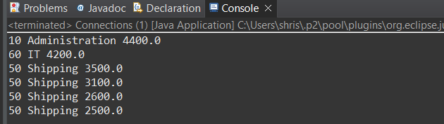

**2] Using preparestatement**

package connection;

import java.sql.*;

public class Connections {

public static void main(String[] args) {

String url = "jdbc:mysql://localhost:3306/hr?serverTimezone=UTC";

String user = "root";

String password = "root";

String query = "SELECT e.department_id, d.department_name, e.salary FROM employees e, departments d WHERE e.department_id = d.department_id ORDER BY e.salary DESC";

try (Connection con = DriverManager.*getConnection*(url, user, password);

PreparedStatement pst = con.prepareStatement(query)) {

ResultSet rs = pst.executeQuery();

ResultSetMetaData rsMetaData = rs.getMetaData();

int columnCount = rsMetaData.getColumnCount();

for (int i = 1; i <= columnCount; i++) {

System.***out***.print(rsMetaData.getColumnName(i) + " ");

}

System.***out***.println();

while (rs.next()) {

System.***out***.println(rs.getString(1) + " " + rs.getString(2) + " " + rs.getString(3));}

} catch (SQLException e) {

System.***out***.println("SQL Exception: " + e.getMessage());

}}}

**Output:**

